Reflex Agent for Room Temperature Control

Overview
This project implements a simple Reflex Agent that monitors and controls air conditioning (AC) in multiple rooms of a house. The agent senses the current temperature in each room, compares it with the desired comfort temperature, and decides whether to turn the AC ON or OFF based on specific rules.

Key Features
- Works for multiple rooms: Living Room, Bedroom, Dining Room, Kitchen, and Washroom.
- Automatically decides when to turn the AC ON/OFF based on temperature difference.
- Keeps track of each room’s last AC state to avoid unnecessary switching.
- Demonstrates AI Reflex Agent behavior in a simple Python simulation.

Class: ReflexAgent

1. Constructor — __init__(self, desired_temp)
Purpose: Initializes the agent with a target temperature and creates a record for tracking each room’s AC status.
Parameters:
- desired_temp (int) → Desired temperature level for comfort (e.g., 22°C).
Attributes:
- self.desired_temp → Stores the preferred temperature.
- self.room_history → Dictionary that keeps track of each room’s last AC state ("AC ON" or "AC OFF").

2. Method — sense_environment(self, room, current_temp)
Purpose: Simulates the sensor’s job of reading the current temperature of a room.
Parameters:
- room (str) → The name of the room being monitored.
- current_temp (int) → The current temperature reading of that room.
Behavior: Saves the current room and temperature. Initializes the room’s AC status as "AC OFF" if it hasn’t been tracked before.

3. Method — analyze_condition(self)
Purpose: Applies simple logic (rules) to determine whether the AC should be turned ON or OFF.
Logic Rules:
- If the current temperature is greater than (desired_temp + 1) → Turn AC ON.
- If the current temperature is less than or equal to (desired_temp - 1) → Turn AC OFF.
- Otherwise, no change in AC state.
Returns: A text message describing the decision made (e.g., "AC Turned ON", "AC Turned OFF", "No Change").

4. Method — execute_action(self)
Purpose: Executes and displays the decision made by the agent for each room.
Output Example:
Living Room: 25°C → AC Turned ON
Bedroom: 21°C → AC Turned OFF

Simulation Flow
Step 1 — Initial Room Temperature Check: The agent reads the current temperature in each room and decides whether to turn the AC ON or OFF for the first time.
Step 2 — Updated Room Temperature Check: After some time, the room temperatures change. The agent senses the new readings and updates its decisions accordingly.

Rooms Monitored
Room Name | Initial Temp | Updated Temp
Living Room | 20°C | 24°C
Bedroom | 21°C | 20°C
Dining Room | 23°C | 21°C
Kitchen | 25°C | 23°C
Washroom | 22°C | 25°C

Output
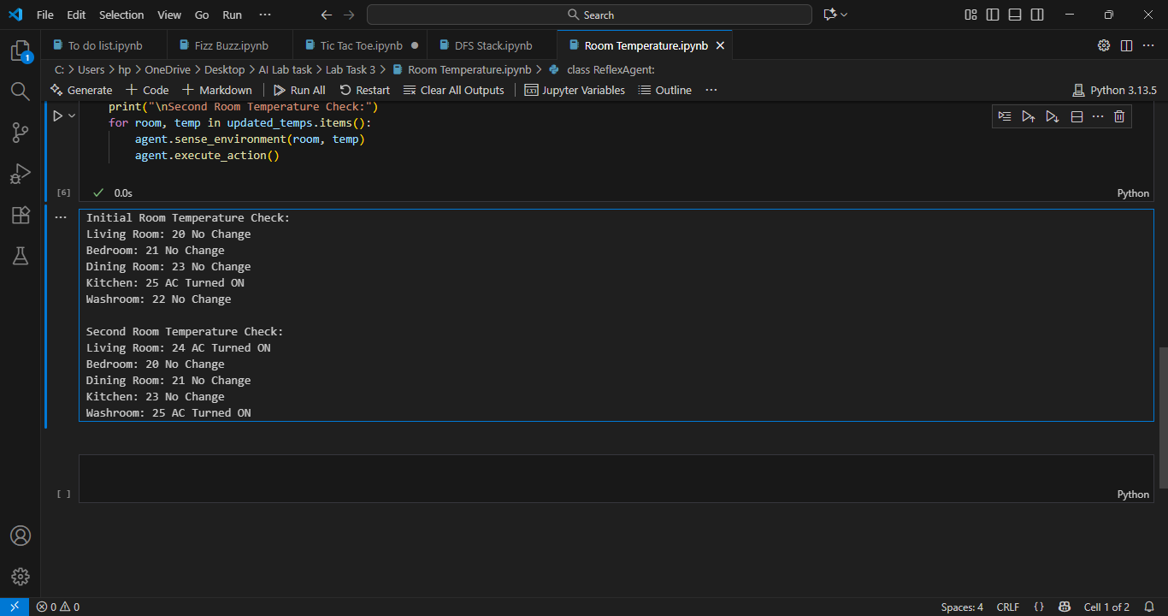

Conclusion
This project demonstrates how a Reflex Agent uses simple condition-based rules to make real-time decisions. It is an excellent example of how Artificial Intelligence can be applied in home automation to maintain comfort efficiently.

